

Lab mst

Student Name: Rahul Maurya UID: 20BCS7260

Branch: CSE Section/Group: 716B

Semester: 4th Subject Name:CN

1. **Aim/Overview of the practical:**

Create a network connection using packet tracer , which shows the working of Switch and Hub. Explain in detail with proper steps.

1. **Task to be done/ Which logistics used:**

To Create a network connection using cisco packet tracer

1. **Steps for experiment/practical/Code**

The step by step process is shown below in pictorial form.

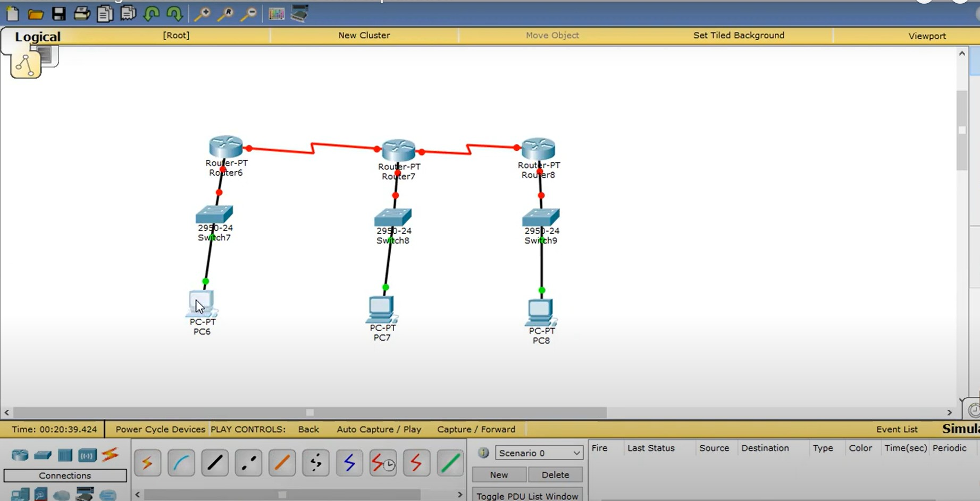

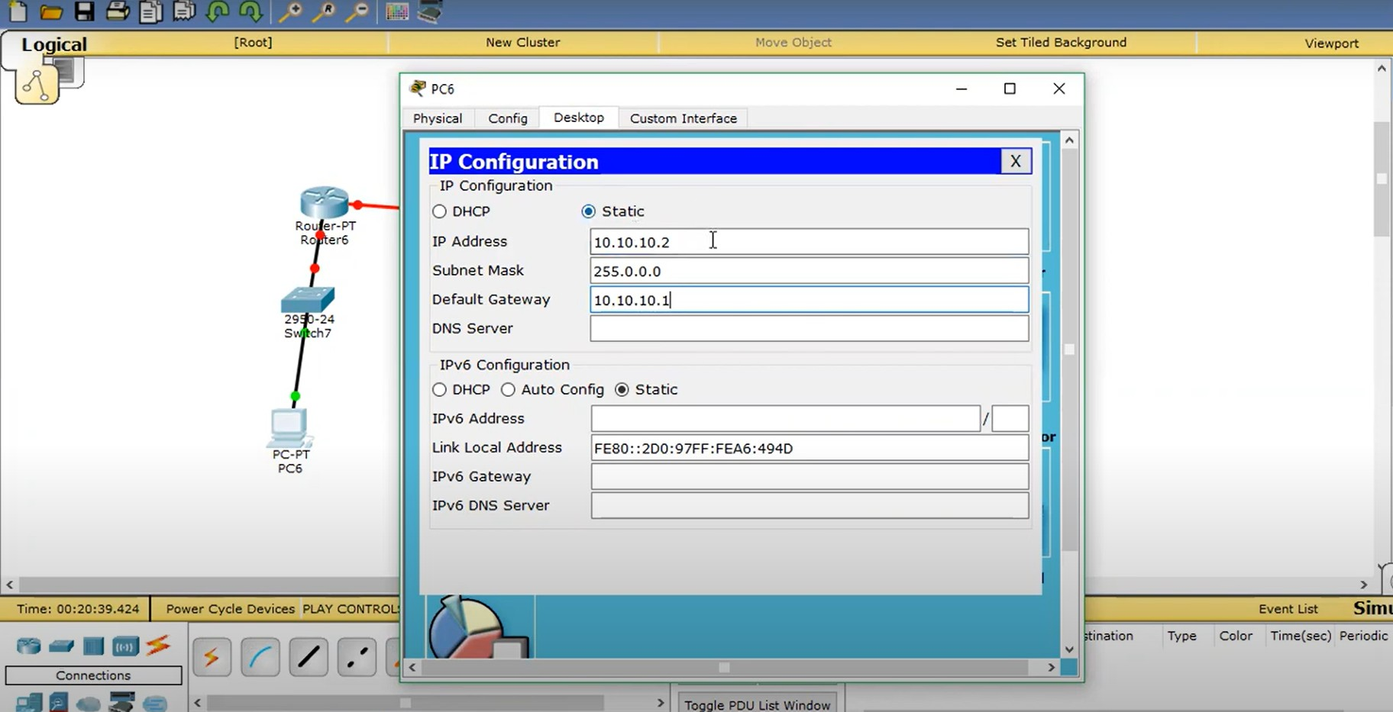

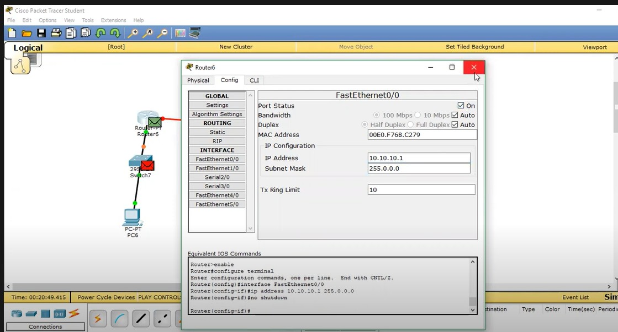

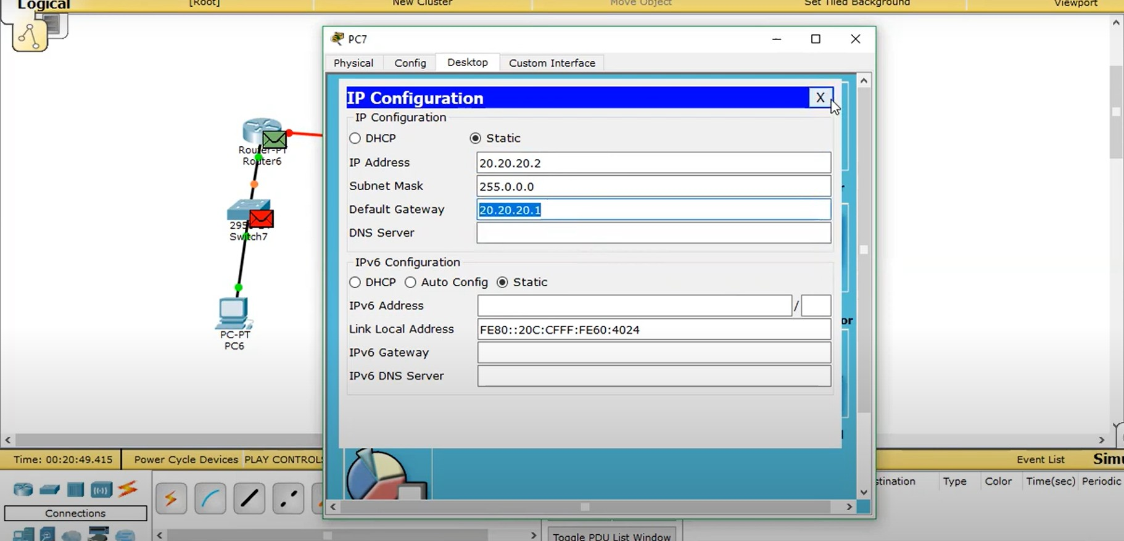

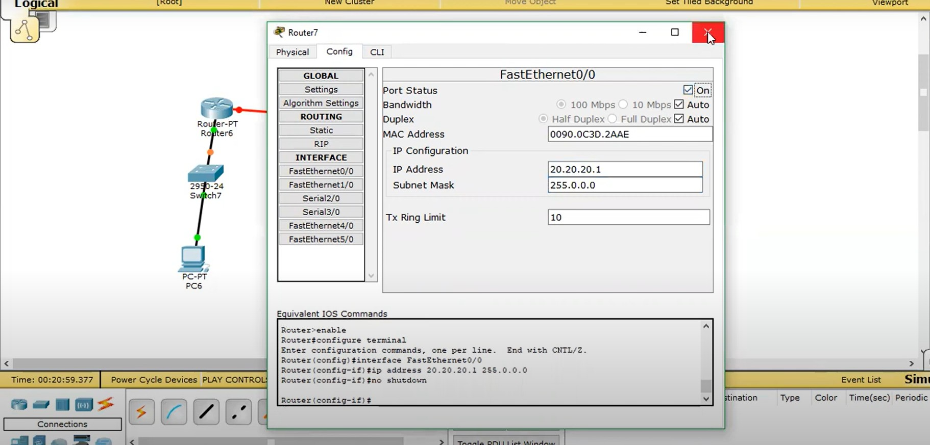

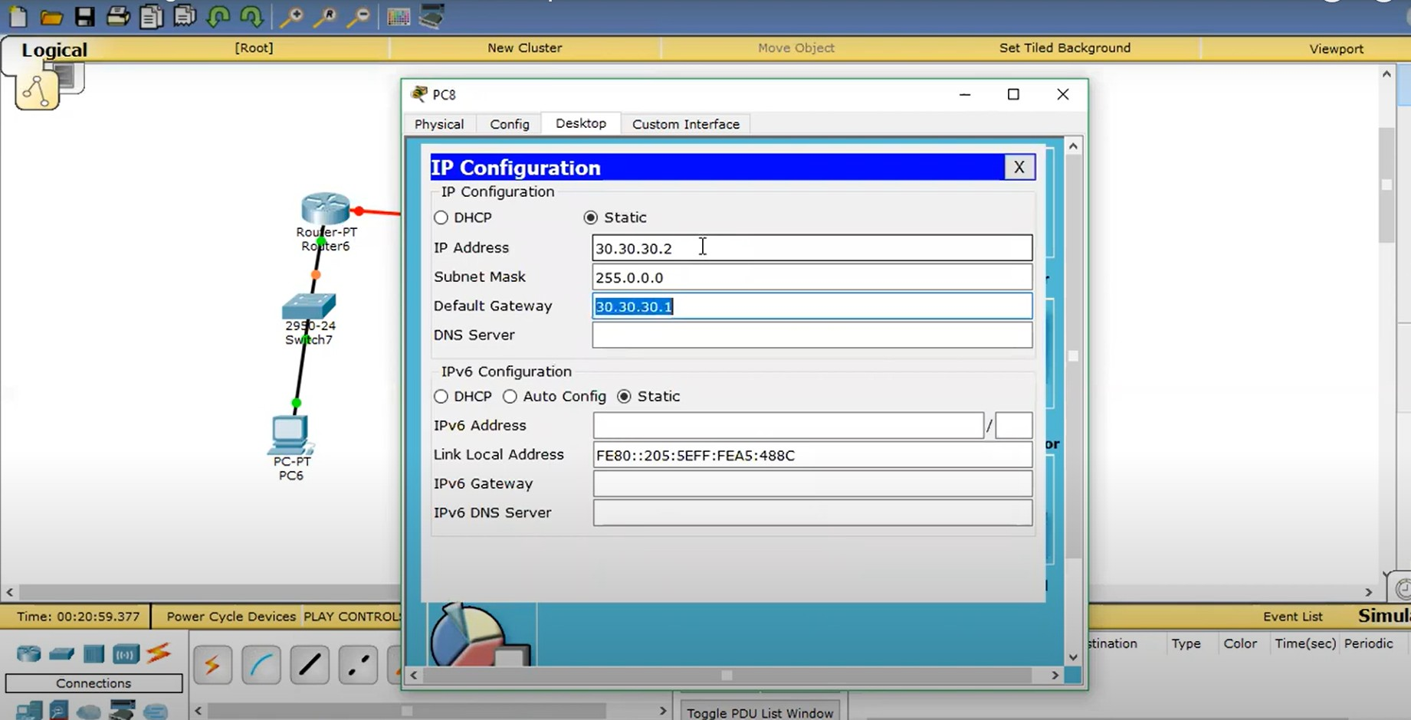

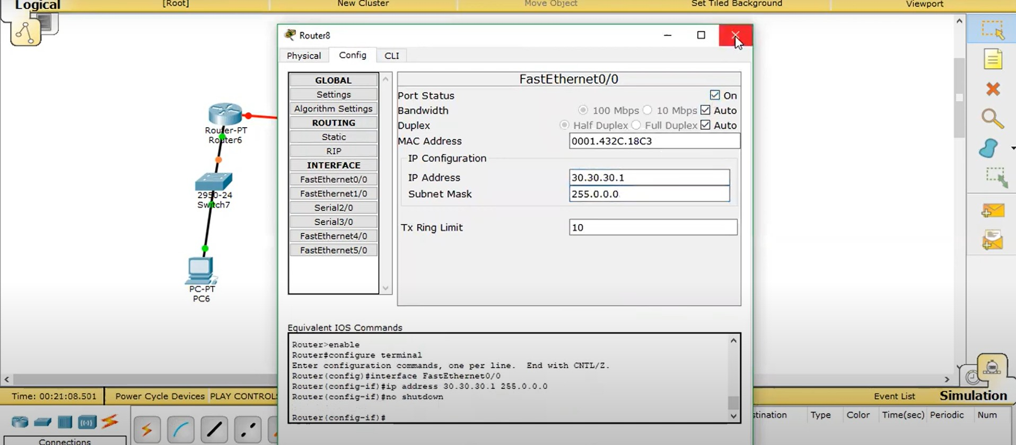

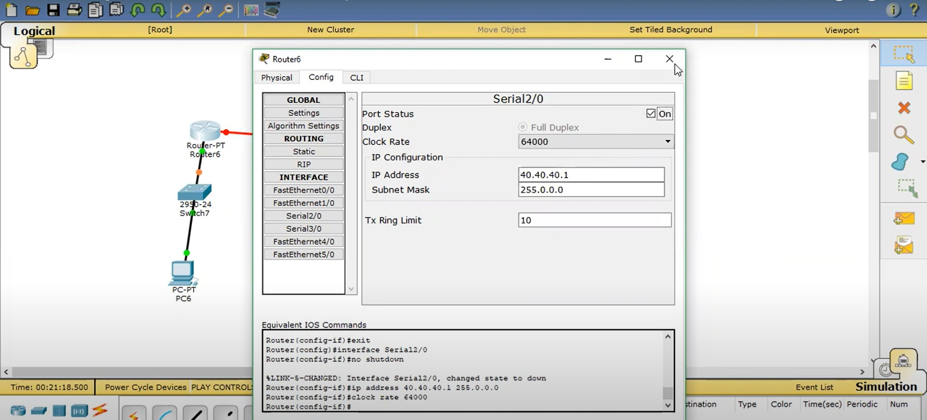

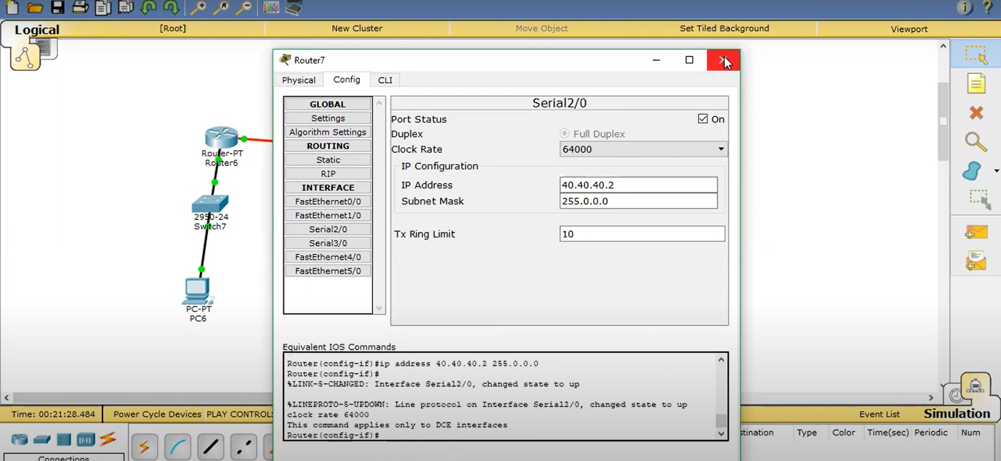

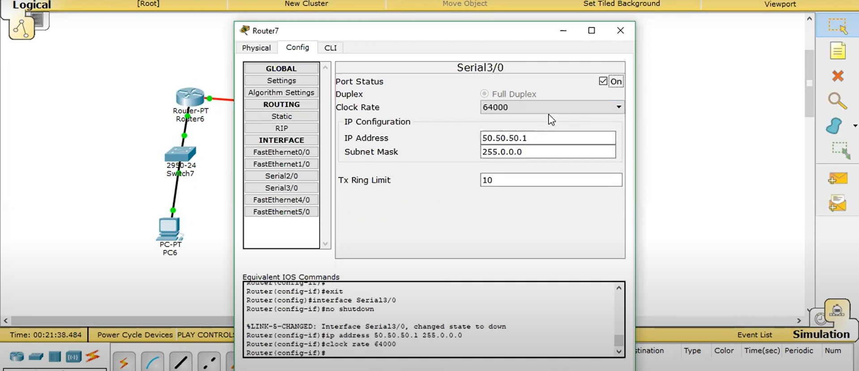

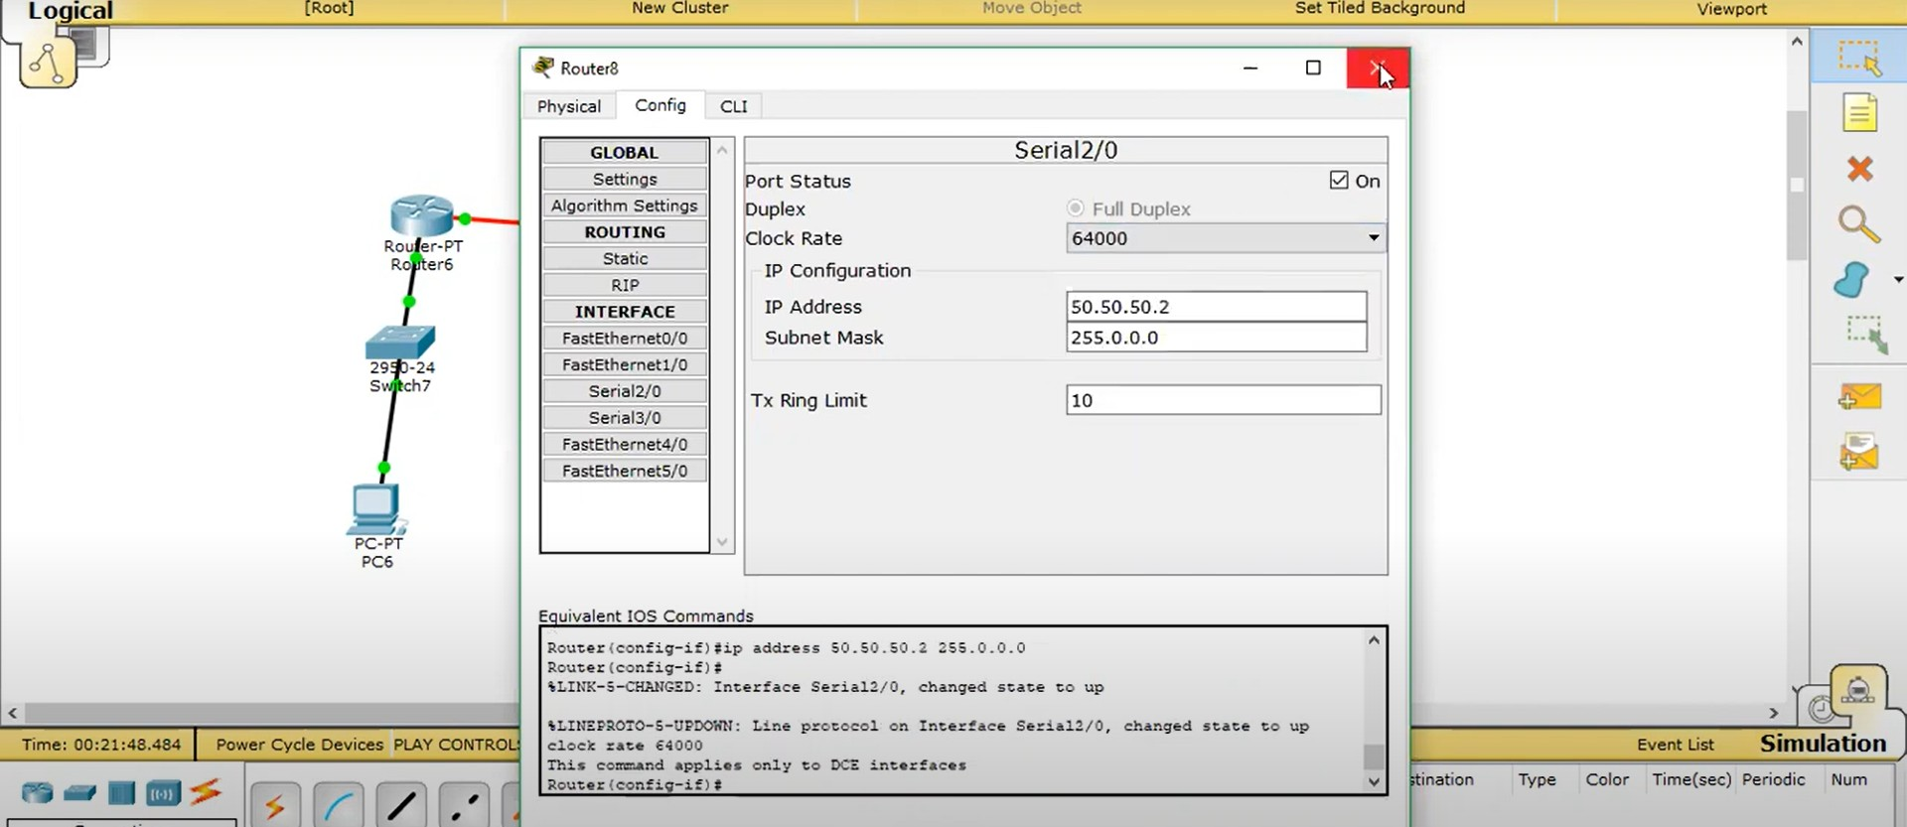

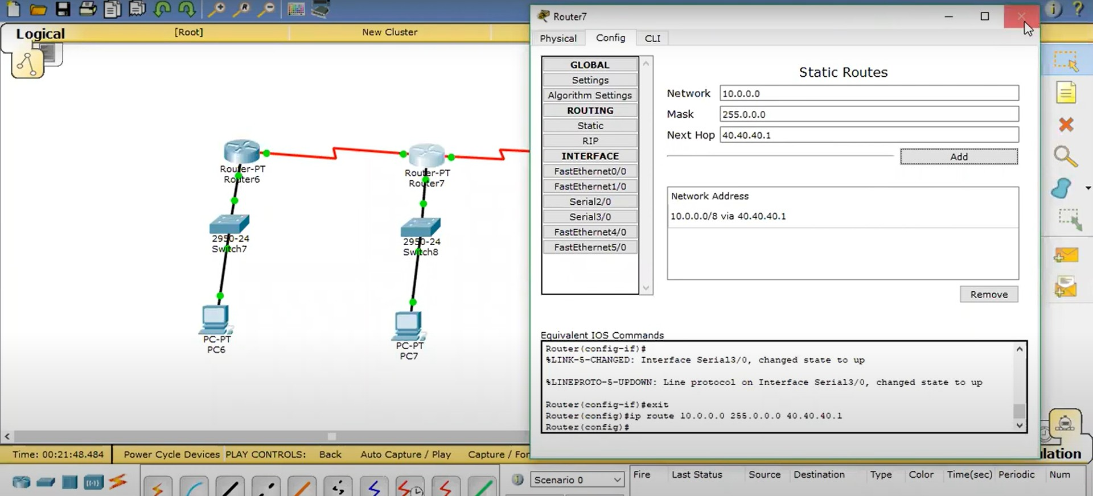

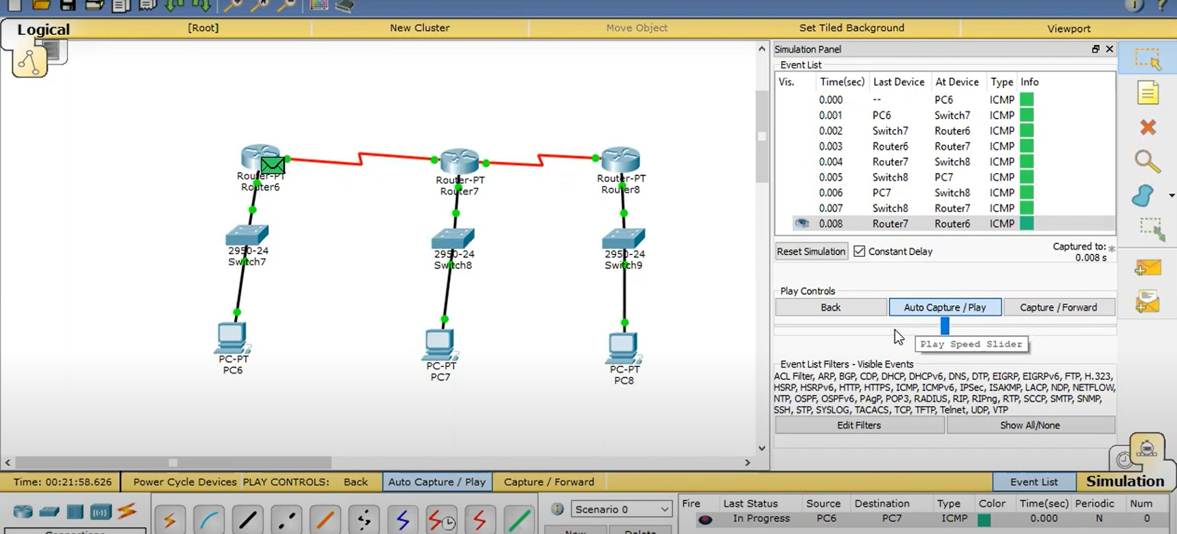

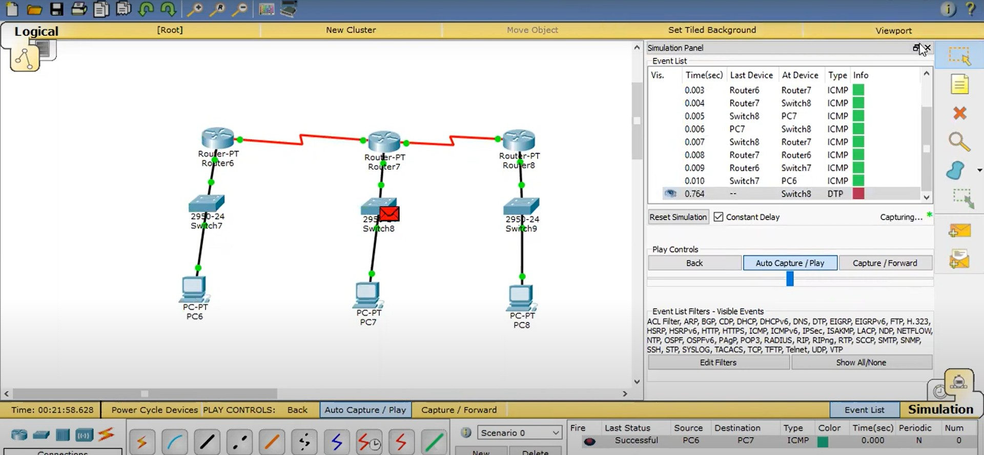

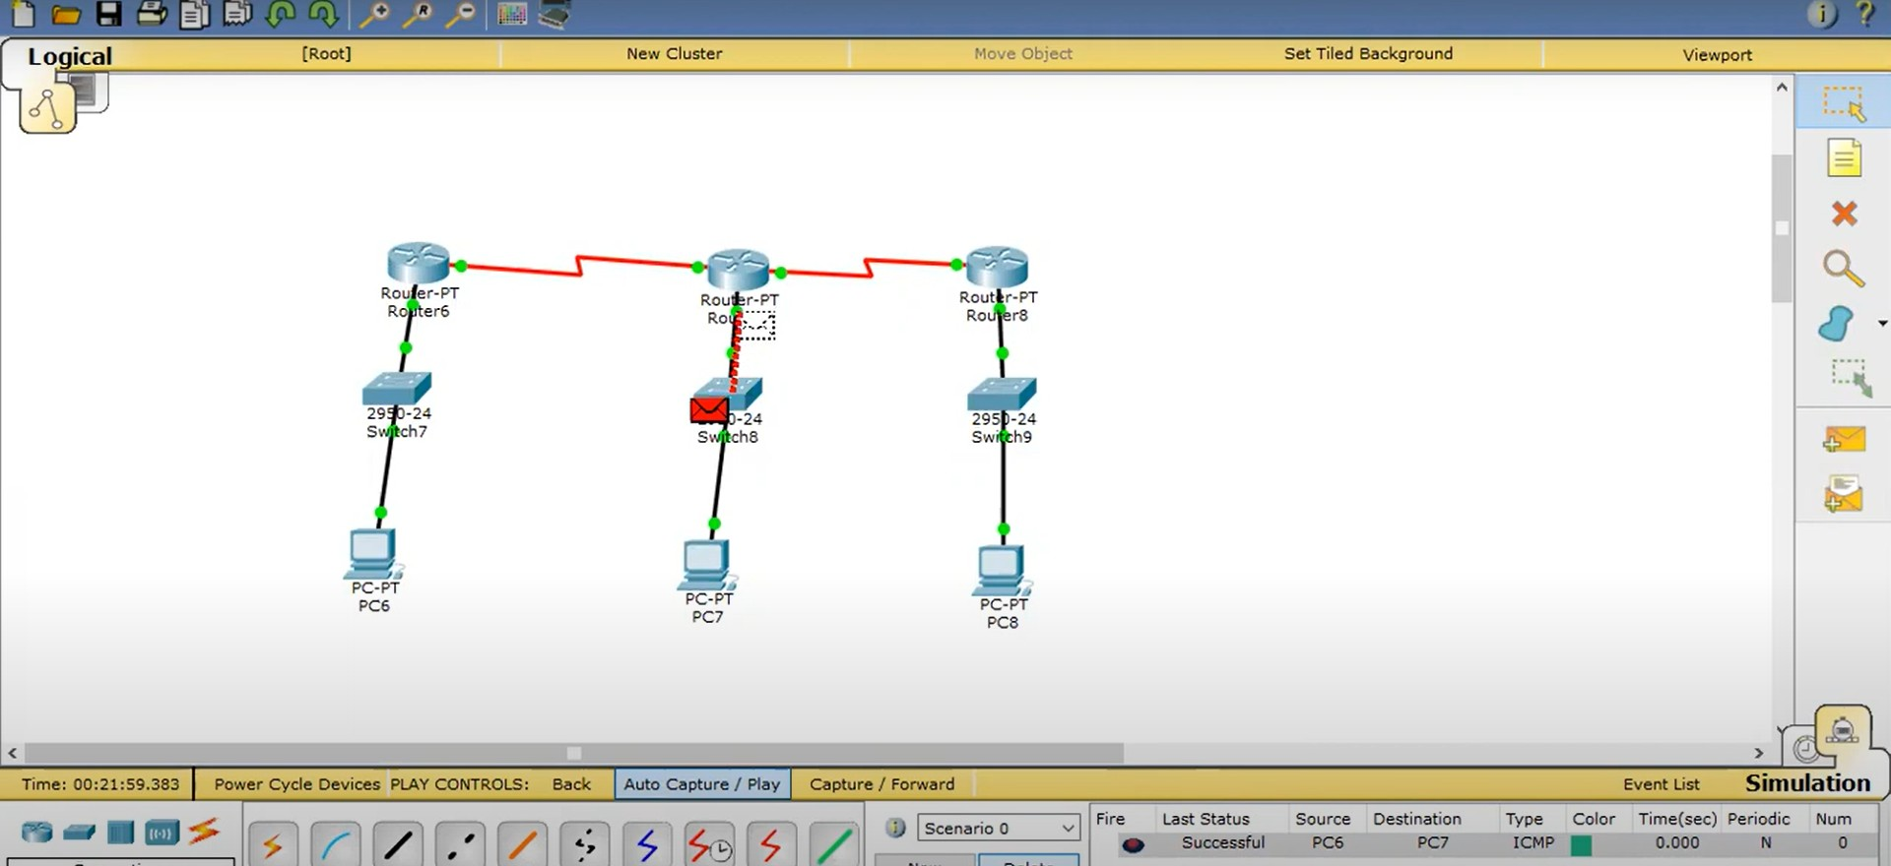

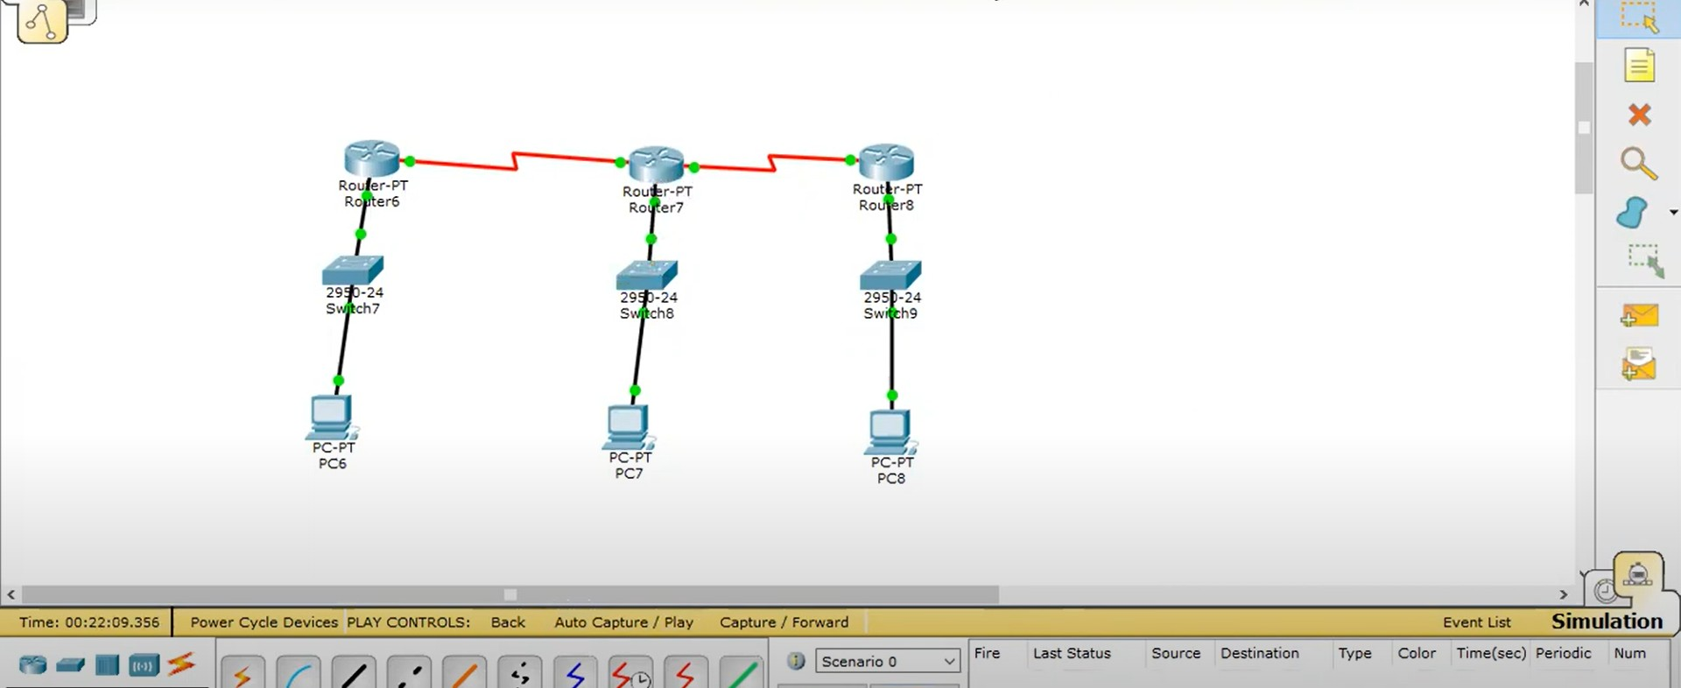

1. **Result/Output/Writing Summary:**

Learning outcomes (What I have learnt):

1.I learnt how the data is transferred through different network.



2.

3.

4.

5.

**Evaluation Grid (To be created as per the SOP and Assessment guidelines by the faculty):**

|  |  |  |  |
| --- | --- | --- | --- |
| Sr. No. | Parameters | Marks Obtained | Maximum Marks |
| 1. |  |  |  |
| 2. |  |  |  |
| 3. |  |  |  |
|  |  |  |  |